**Ideation Phase**

**Brainstorm & Idea Prioritization Template**

|  |  |
| --- | --- |
| Date | 19 September 2022 |
| Team ID | PNT2022TMID17255 |
| Project Name | Real - Time Communication System Powered by AI for Specially Abled |
| Maximum Marks | 4 Marks |

**Brainstorm & Idea Prioritization Template:**

Brainstorming provides a free and open environment that encourages everyone within a team to participate in the creative thinking process that leads to problem solving. Prioritizing volume over value, out-of-the-box ideas are welcome and built upon, and all participants are encouraged to collaborate, helping each other develop a rich amount of creative solutions.

Use this template in your own brainstorming sessions so your team can unleash their imagination and start shaping concepts even if you're not sitting in the same room.

**Step-1: Team Gathering, Collaboration and Select the Problem Statement**

* In our society, we have people with disabilities. The technology is developing day by day but no significant developments are undertaken for the betterment of these people. Communications between deaf-mute and a normal person has always been a challenging task. It is very difficult for mute people to convey their message to normal people. Since normal people are not trained on hand sign language.
* The project aims to develop a system that converts the sign language into a human hearing voice in the desired language to convey a message to normal people, as well as convert speech into understandable sign language for the deaf and dumb. We are making use of a convolution neural network to create a model that is trained on different hand gestures. An app is built which uses this model. This app enables deaf and dumb people to convey their information using signs which get converted to human-understandable language and speech is given as output.

**Step-2: Brainstorm, Idea Listing and Grouping**

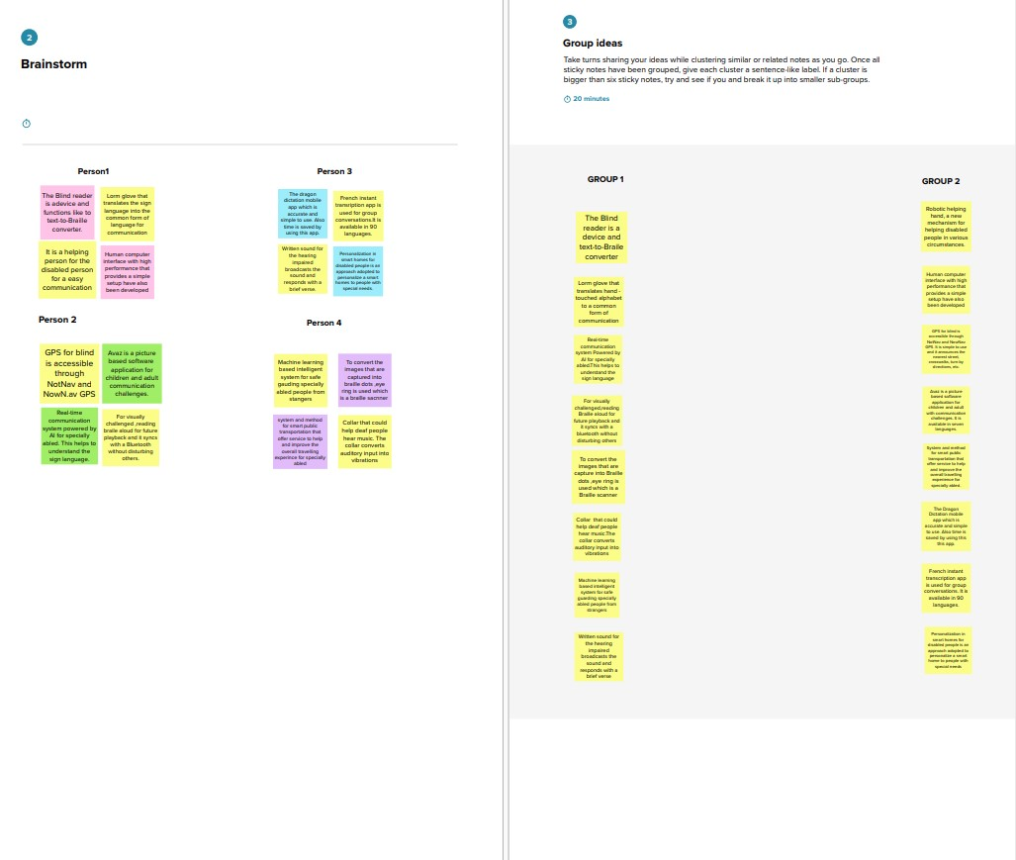

**Step-3: Idea Prioritization**

